Navigation Design

Definition
# Source: AI Source: Provided by: [Data Path: Persons Table -> ID Column: 1, Name_En Column: Motasem Essam] -> From: [Chatgpt (GPT‑5 Mini)] on [2/12/2026]
Navigation Design is a web design technique that focuses on creating menus, links, and structures that help users move easily through a website and find the information they need.

Simple Definition
# Source: AI Source: Provided by: [Data Path: Persons Table -> ID Column: 1, Name_En Column: Motasem Essam] -> From: [Chatgpt (GPT‑5 Mini)] on [2/12/2026]
Navigation Design = organizing links and menus so users can easily explore a website.

How Navigation Design Works
# Source: AI Source: Provided by: [Data Path: Persons Table -> ID Column: 1, Name_En Column: Motasem Essam] -> From: [Chatgpt (GPT‑5 Mini)] on [2/12/2026]
• Creates menus (top menu, side menu, footer links)
• Uses clear labels for links (e.g., Home, About, Contact)
• Organizes pages in a logical structure
• Provides internal links between pages
• May include dropdown menus or breadcrumbs
• Ensures navigation works on all devices

Purpose of Navigation Design
# Source: AI Source: Provided by: [Data Path: Persons Table -> ID Column: 1, Name_En Column: Motasem Essam] -> From: [Chatgpt (GPT‑5 Mini)] on [2/12/2026]
• Help users find information quickly
• Improve user experience
• Guide users through the website
• Reduce confusion and frustration
• Increase time spent on the website

Advantages
# Source: AI Source: Provided by: [Data Path: Persons Table -> ID Column: 1, Name_En Column: Motasem Essam] -> From: [Chatgpt (GPT‑5 Mini)] on [2/12/2026]
• Easy and clear navigation for users
• Improves user experience
• Helps users find content faster
• Makes the website more organized
• Supports better website structure

Disadvantages
# Source: AI Source: Provided by: [Data Path: Persons Table -> ID Column: 1, Name_En Column: Motasem Essam] -> From: [Chatgpt (GPT‑5 Mini)] on [2/12/2026]
• Poor design can confuse users instead of helping them
• Complex menus can overwhelm visitors
• Requires careful planning and testing
• Can take time to design a good navigation structure
• Must be adapted for different screen sizes (responsive navigation)

Examples
# Source: AI Source: Provided by: [Data Path: Persons Table -> ID Column: 1, Name_En Column: Motasem Essam] -> From: [Chatgpt (GPT‑5 Mini)] on [2/12/2026]
• A top navigation bar with links like Home, Services, Contact
• A hamburger menu on mobile devices
• Dropdown menus for subcategories
• Breadcrumb navigation (Home > Category > Page)
• Footer links for important pages

Difference Between Navigation Design and Other Techniques
# Source: AI Source: Provided by: [Data Path: Persons Table -> ID Column: 1, Name_En Column: Motasem Essam] -> From: [Chatgpt (GPT‑5 Mini)] on [2/12/2026]
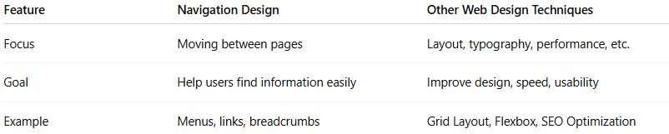
Feature | Navigation Design | Other Web Design Techniques
Focus | Moving between pages | Layout, typography, performance, etc.
Goal | Help users find information easily | Improve design, speed, usability
Example | Menus, links, breadcrumbs | Grid Layout, Flexbox, SEO Optimization

